|  |  |
| --- | --- |
|  |  |
| **UE_EN.bmp** |

***System of Environment-Economic Accounts (SEEA)***

**Experimental Ecosystems/Natural Capital Accounts for Mauritius, 2000 – 2010**

**Part 2: Methodology, Accounting Tables and Production Process**

# Introduction

The production of Ecosystems/Natural Capital for Mauritius during the period 2000 to 2010 for Mauritius has been undertaken in the national context of the implementation of sustainable development policies illustrated by the ‘Maurice Ile Durable’ project and in the international context in close relation to the 2005 ‘Mauritius Strategy’ for the further Implementation of the Programme of Action for the Sustainable Development of Small Island Developing States (known as Barbados Programme of Action (BPoA).

# There has seldom been any assessment of ecosystems in Mauritius and the level of deterioration and/or enhancement is practically unknown. This lack of quantitative assessment, along with the increasing demand for information on environmental sustainability has led to the initiative to develop accounts for the ecosystem, in line with projects such as the Maurice Ile Durable. This has also been felt internationally through initiatives such as the Millennium Ecosystem Assessment, The Economics of Ecosystems and Biodiversity (TEEB), the Stiglitz-Sen Fitoussi Report, the World Bank WAVES project and the CBD Strategic plan for Biodiversity 2011-2020, which are all within the purview of ecosystem accounts.

# In 1992 at the Rio Earth Summit, environmental accounts were proposed as a way of integrating the environment in decision-making (United Nations 1993). As a result, a handbook for integrated environmental and economic accounting was published. Updated in 2003, it forms the basis of the international System of Integrated Environmental-Economic Accounts (SEEA) which employs accounting concepts and structures compatible with the System of National Accounts (SNA). It enables stocks and flows of environmental assets (natural resources, land and ecosystems) to be represented in physical as well as financial measures.

# The SEEA Central Framework was endorsed in 2012 by the UN Statistical Commission and is supplanted with a Volume 2 which contains recommendations for experimental ecosystem accounts[[1]](#footnote-1). The purpose is to assess ecosystems extent and condition and their possible degradation of enhancement as a result of human activities. It aims at providing a better understanding of the condition and sustainability of market and non-market goods and services made available by healthy ecosystems.

# This report takes place in the experimentation process of the ecosystem accounts. It learns from other experiences such as the project lead in Europe by the European Environment Agency. It relies as well on previous environmental accounts and assessments in Mauritius such as the water accounts (SEEA-Water) and experience gained in monitoring climate change variables and biodiversity. It is important to state clearly at this stage that the project carried out was experimental and aimed at delivering a proof of concept regarding the accounting framework and the demonstration of its feasibility in a short period of time, using existing data. Whereas the chapters below show eloquently the interest of the approach and first results, it has to be clear that further validation of these results is necessary to meet the statistical and scientific quality standards. The application has been made possible by the wide cooperation of many organisations in Mauritius and the capacity of Statistics Mauritius to collect a large amount of data in very various areas. The intrinsic quality of these data is out of doubt but accounting is first of all a matter of integration. It requires common formats and the some completeness of the data. Putting data together has been possible for year 2010, to a large extent but not completely. Missing data had to be estimated and such estimations need be reviewed by experts and scientists and revised. When reformatting and integrating data in the ecosystem capital accounting framework, uncertainties have been detected regarding for example the exact date of the sugar cane map provided or the exact date or coverage of an “old” urban map which has been used with care. Regarding historical data, they are of course more fragile and incomplete.

# Operational ecosystem capital accounts need further work and will require additional work. Because ecosystem accounts speak of spatially explicit units, it is obvious that there is a need for a diachronic monitoring of land cover change. The land cover map produced during the project is made from the best data available for 2008-2010, based for most of them (not all…) on the analysis of the LAVIMS image (aerial ortho-photographs) of 2008 and subsequent applications. There is no equivalent for the past, although it is well known that land cover change has been an important driver, would it be urban sprawl linked to demography and tourism development or the important mutations in sugar cane cultivation and industry. Producing reference land cover data with existing satellite images from 1990, 2000 in a consistent way with the 2008-2010 image (and updating it…) is a priority. Another priority is to foster the involvement of the various players in the process, beyond the supply of data, into review, validation and assessment of the accounting results.

The set of Accounts in this report covers land cover, carbon/biomass, and water and biodiversity for 2010, with some retrospective view to 2000 when possible. It combines data on nature and socio-economic statistics on population, housing, agriculture, fishery… Because of the duration of the project, the emphasis was put on the production of physical accounts – as it is recommended in the SEEA. Valuation in money of economic benefits and costs is left to further developments.

The spatial dimension is fully considered in the preparation of the accounts as they are based on basic statistical units (BSU) used for calculations. The UN SEEA Part 2 on experimental ecosystem accounts describes BSUs as small spatial areas which can be defined at multiple scales. It is suggested that BSUs should be formed by delineating tessellations (small areas e.g. 1 km2), typically by overlaying a grid on a map of the relevant territory, but they may also be land parcels delineated by the cadastre. In turn, BSUs can be grouped on a spatial basis according to common characteristics (e.g. land cover types) or their belonging to geographic areas (e.g. to river catchments). Because data are managed with a Geographical Information System (GIS), accounting results can be reported according to various zonings, in particular administrative units.

Being experimental, the SEEA-“Ecosystem accounts” doesn’t provide precise practical guidelines for data collection and processing. The experiments starting now in various countries will have to define them.

# Putting the SEEA Part 2 Experimental Ecosystem Accounts at work

* 1. **Ecosystem accounting: the perspective**

The impact of economic activities on the environment is generally a function of total population, per capita consumption, waste generation and the type of technologies used. The case for Mauritius may also include the effects of tourism, consumption behaviour, as well as scale of productions of goods and services. The SEEA shows how economic activities impact on the environment through consumption of resources such as energy, water and materials used in production. For instance, consumption of energy results in atmospheric emissions while water use may cause water shortages and generation of waste water and water pollutants. The SEEA therefore shows the Environment-Economic relationship by relating environmental pressures in physical terms to economic drivers expressed in monetary terms. It facilitates a more in-depth analysis of environmental concerns, since the different modules are broken down by sectors of the economy.

The SEEA Part 1 Central Framework is an extension of the SNA to which it provides additional insights regarding materials and energy used for production, natural assets which supply them (subsoil reserves, forests, fish stocks, water bodies…), the monetary value of these assets and of their depletion, and of the expenditures devoted to environmental protection and natural resource management. The consistency of the SEEA Part 1 is given by the SNA itself, its classifications of commodities and industries, its rules of valuation and to a large extent its definition of natural assets – read economic-natural assets owned and managed in view of benefits.

Figure 1: SNA and SEEA Part 1 and Part 2

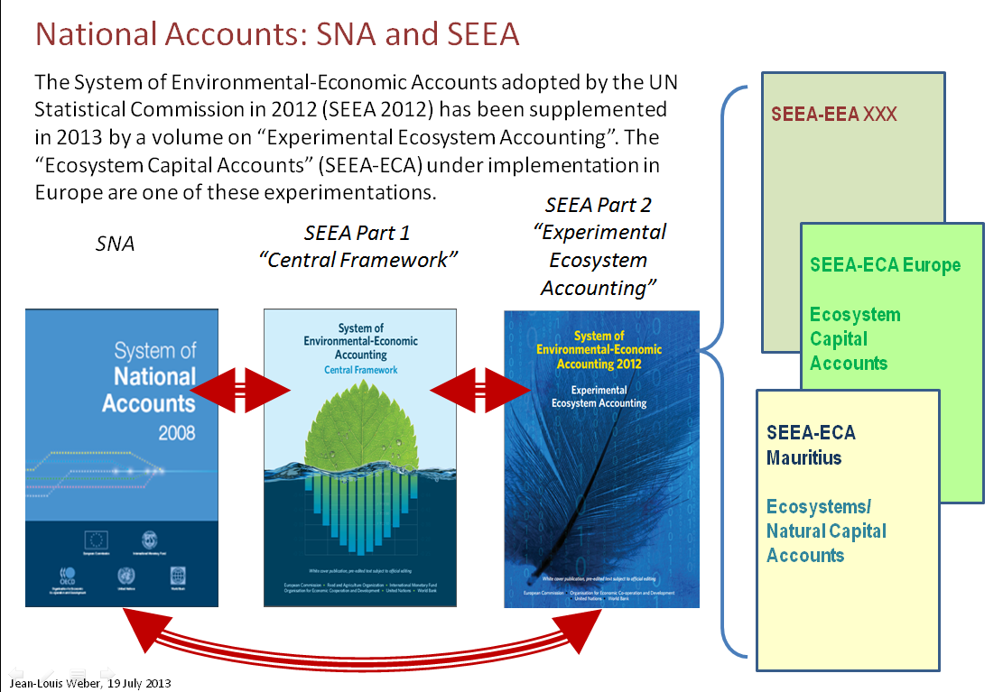

While resource depletion has a strong meaning regarding sustainability, it doesn’t reflect that living and cycling natural systems are more than stores of materials, that they are renewable and that the intensity and condition of their use is vital considering the future services that they deliver. Depletion refers to the “weak sustainability” paradigm of maintenance of the flow of income and of the total wealth of various kinds of produced, human or natural capital which are assumed being broadly substitutable. Instead, considering ecosystem capacity to reproduce themselves and renew the many services they supply to the economy and out of the economy to public wellbeing requires considering them as a “critical” natural capital which cannot be substituted with other (in particular with produced capital) but which potential should be maintained. This is commonly called “strong sustainability” and refers in addition to quantitative extent (surface, volume, mass, energy…) to concepts of ecosystem health, resilience, functions and sustainable capacity to deliver services. Note that strong sustainability doesn't mean hard conservationism, as long as ecosystem functions can be developed as well as degraded by human activities, making room for mechanisms of mitigation or compensation (between ecosystems) when human need lead to damaging ecosystems in one place. This vision underlines the ecosystem accounts which purpose is to measure degradation (and enhancement where it happens) and the human responsibility in the process. Because not all aspects of ecosystems are accounted but mostly what is part of their relation to human activity, we will speak of ecosystem capital accounts (ECA). The use of the term of capital doesn't imply any acceptance of the standard capital model of the conventional economic theory where the capital equals the net present value of expected future benefits. Capital is in ECA considered as a set of private and public, market and non-market assets, a patrimony to be forwarded from generation to generation. Such capital cannot be valued in money, only a few of its component can be, when they have a market value. Instead, the ecosystem capital has a specific value which can be measured in different units than money and be used to assess our responsibility – our accountability in the use of Nature.

* 1. **A quick description of the accounting framework**

Multiple approaches for ecosystem accounting have been followed so far, exploring one or the other dimension without presenting the broad picture. Because the issue is complex, there is the need for a holistic view and a plan to avoid being lost in details. The approach to ecosystem capital accounts is definitely macroscopic. It tries to capture the elements which are essential to answer the central question: is this ecosystem been degraded by human activities?

The approach is outcome oriented: beyond the minimum of data and rules (presented below), there is little standardisation of data “a priory”. The broad categories of land cover are universal; the details are country or region specific. The variability of biodiversity is huge across the planet and the data even more heterogeneous; but biodiversity degradation is a clear symptom of ecosystem distress.

The approach is consistent with the principles of double and quadruple entry accounting (SNA 2008). This is indispensable considering the ecosystem themselves and their interrelations as well as the relation between ecosystem accounts and the SNA. Partial accounts have limited use and entail the risk of misleading messages to decision makers because only one aspect is considered.

Ecosystem capital accounts are integrated which means more than some harmonisation of classifications: the choice of a common measurement unit. The monetary accounts aggregate values which are settled by the economic agents. They don’t aggregate quantities and when they record them (inventories of a company, employment in the national accounts), it is in the form of additional tables which don’t contribute to the calculation accounting result: benefit, loss, net worth… The possibility of aggregating quantities is always limited and requires always the acceptance of an equivalence regarding the qualities attached to those quantities. For example, the total land surface of a country assumes that all kinds of land use are equivalent – have an equal value. To move out of this valuation, it is possible to attach different weights to different pieces of land (this is done in the Landscape/biodiversity accounts here land is weighted with its ecological potential – see below). The same could be said of the Green House Gases “equivalents”, the tonne oil “equivalent” (toe) to aggregate various forms of energy etc… ECA propose such a unit-equivalent to aggregate ecological values linked to three main ecosystem functions in the domains of biomass, water and “systems and species” biodiversity. For each component, values are calculated by combining the result of quantitative balances which are of SEEA Part 1 type (intensity of use of the biomass, water and biodiversity resources) and diagnosis of ecosystem health based on available indicators. The three components are lastly averaged. In ECA, the resulting composite unit is called “Ecosystem Capability Unit” (ECU). It will be used to measure changes in the quantity and quality of any kind of ecosystem.

Considering operational messages, the measure ecosystem degradation in integrated physical accounts can be interpreted as an ecological debt (a maintenance which is not done) and recorded as such in a specific balance-sheet. The cost of restoration from degradation can be also calculated. Lastly, the ecosystem services recorded in physical terms in the accounts can lead to better valuation than what could be done (and is presently done) without accounts. Figure 2 summarises the scope of the accounts.

Figure 2: Scope of Integrated Ecosystem Capital Accounts

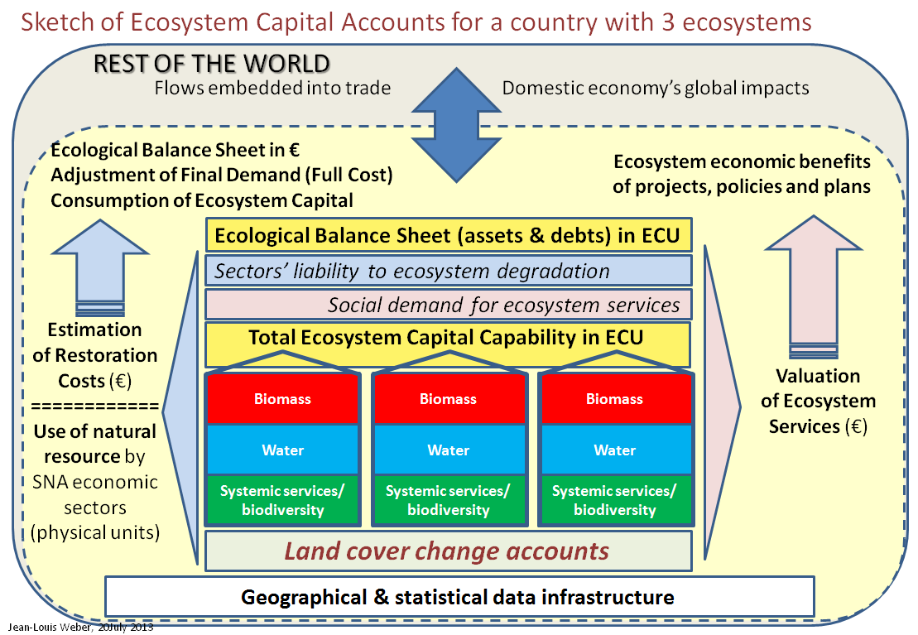

At the core of integrated ECA are accounts for each ecosystem of biomass/bio-carbon, water and systemic services related to biodiversity. These accounts relate to statistical units which are defined from their spatial characteristics, areas or linear features (in the case of rivers). The data infrastructure of statistics and monitoring data is build up accordingly. In the case of inland ecosystems, the land cover and land cover change accounts play a major role in for structuring the information as well as in detecting the main trends.

On top of each individual ecosystem account is calculated a value in ecosystem capability units (ECU), a composite measurement unit which is common to all ecosystems and can be aggregated[[2]](#footnote-2). Measurements in ECU can then be used to establish three accounts:

* The Balance-sheet of ecological debts and credits
* The account of the social demand for ecosystem services, which is of particular importance considering systemic services which are assessed indirectly in proportion of ecosystems extent and health as well as of their actual use by people.
* The account of sectors liability to ecosystem degradation which encompasses both balances of resource use of the type defined in the SEEA part 1 and the recording of ecosystem degradation or enhancement. This account connects economic sectors and ecosystems on a spatial basis, which requires resampling statistics to space. In that way, it is an important gateway between the macro approach of the national accounts and accounts at the micro level – for companies, farms or local governments.

Beyond measurements in ECU and on the basis of physical accounts, monetary valuations can be carried out. A first approach is by assessing the costs of restoring the ecosystem from degradation. Theses are unpaid costs, a piece of capital depreciation which is not recorded in accounting books – what economists call externalities. Such restoration costs could be added up to the final demand of the national accounts to measure it at the full cost instead of the transaction prices as presently done. ECA restoration costs can be assessed on the basis of statistics of actual costs calculated by agronomists, foresters, water agencies for restoration programmes as well as opportunity costs of alleviating pressure on ecosystems by changing crop types or setting land aside from use to let ecosystems recover.

Another type of valuation relates to the services supplied by ecosystems. Part of them is input to production and has a value given by the market. This value is a joint value economy-ecosystem and it can be of interest to disentangle the two components, using for example econometric models. Other services have little or no value because their legitimate owners are not in a position to negotiate the rent attached to them; it is typically the case of what is called bio-prospecting where pharmaceutical companies use natural molecules from wild ecosystems without payment. This case has been addressed in the ABS Protocol of the CBD negotiated in the Aichi-Nagoya COP 10 in 2010; the protocol defines rules for Access to genetic biodiversity diversity and Benefits Sharing. Lastly, many ecosystem services are public goods which are not valued by the market because there are no property rights and transactions. In a vision of welfare economics, the value of such services can be calculated by different methods which have been experimented in many researches such as TEEB, WAVES (The World Bank) or VANTAGE (UNEP). Methods are based according to services, issues and purposes of valuation on shadow prices calculated from replacement costs, “production” costs, transport cost, hedonic prices and contingent valuation (by sampling survey to individuals asked to express their preferences). Once services are valued, additional calculations of capital value can be done in reference to the standard economic model in view of calculating ultimately aggregates such as Total Wealth (WB) or Inclusive Wealth (UNEP/UNU).

It is not the place here to run a discussion of the interest and issues of valuation of ecosystem services. Two remarks however need to be done. The first one is that valuation methods have proved their interest and feasibility in the context of cost benefit analysis (CBA), generally for projects, specific sectors or areas where the terms of the analysis can be established in a safe way. Aggregation of CBA results to national accounts remains very controversial. The second remark is that the SNA is not only made of core accounts connected by double and quadruple entry accounting rules. It includes as well so-called functional analysis aimed at providing detailed, enlarged and comprehensive accounts of social functions such as education, health, social security, research and development or environmental protection. Functional accounts are commonly called “satellite accounts” by opposition to “core accounts”. The aggregates that satellite accounts allow computing (e.g. the National Expenditure in a given domain) can be compared between themselves and to the SNA aggregates, e.g to GDP. But the various accounts cannot be added up, unlike sectors, industries and commodities in the core accounts. The reason is that a given expenditure can be recorded in several accounts; for example, research on environmentally cause disease is recorded in the accounts for ‘environment’, ‘health’, ‘research’ and even ‘education’ if carried out by a university laboratory. If we accept that valuation of ecosystem services is of the kind of ‘functional accounts’, theoretical issues such as inconsistency of prices, double counts (when services can be private as well as public) of incompleteness have little importance. Numbers can be compared (in the CBA spirit) even though they cannot be aggregated.

This is to say that ecosystem services accounts are ‘satellite accounts’ of the ‘core accounts’ of ecosystem extent and health (potential, capacity…). ECA core accounts are accounts of ecosystems defined as biophysical entities, not as the total of ecosystem services.



* 1. **A work plan for producing ecosystem accounts**

The logical sequence of producing ecosystem capital accounts follows these steps:

1. Data collection and pre-processing:
   1. Geographical information infrastructure: administrative boundaries (country, districts, municipalities), limits of river basins, relief, rivers, roads…
   2. Thematic geographical layers: land cover, urban areas, forests, high natural value areas, soils, aquifers *(note that in the case of Mauritius no land cover map could be used for accounting and that it had to be produced at an initial stage).*
   3. In situ monitoring data: species biodiversity, pollution, meteo
   4. Earth Observation by Satellite data: vegetation index, Net Primary Production, Evapo-Transpiration…
   5. Socio-economic statistics: population, agriculture, forestry and fisheries, water use (municipal use, irrigation…)
      1. Definition of statistical units for accounting [1], general principles
         1. Ecosystem units
         2. Ecosystem services
      2. Land cover map and accounts
      3. Definition of statistical units for accounting [2], implementation with land cover and other geographical data
      4. Biomass carbon account
      5. Water account
      6. System and species biodiversity account
      7. Synthesis of v., vi., and vii., calculation of ECU values
      8. Functional analysis of ecosystem services demand/ ECU
      9. Functional analysis of sector’s liability to ecosystem degradation/ECU
      10. Establishment of the Ecological Balance-Sheet/ECU by ecosystems and sectors
      11. Valuation of selected ecosystem services
      12. Estimation of ecosystem restoration costs

The present study of SEEA-ENCA for Mauritius covers steps i. to vii.

1. **Data collection and pre-processing:**

Data collection has been carried out in the first phase of the projects and described in a previous report. Annex I summarises the various contributions by Mauritian agencies. The data collected are abundant, even though there is room for improvement in particular regarding land cover change, meteorological data, sugar cane industry and the marine environment.

The abundance of data has generated an important workload for pre-processing them regarding completeness, harmonisation of geographical projections, consistency between geographical and statistical breakdowns, inter-alias. Note that this investment results in a consistent set of data which can be reused in the continuation of this project or in the context of different research. The list of datasets delivered to Statistics Mauritius is provided in Annex ii.

1. **Definition of statistical units for accounting [1], general principles**

The first step in accounting is to define the statistical units which will be used. In the case of economic accounts, these units are entities such as companies, households, government bodies identified according to legal or institutional criteria; they produce goods and services labelled by the market or accomplish transactions with clearly defined legal status. These statistical units pre-exist the accounting compilation and they just need be grouped by nature or/and activity.

In the case of ecosystems, not such units exist; they have to be defined. The general proposals of SEEA Part2 refer for ecosystems to the spatial basis of statistical units’ definition and a hierarchy from Basic Statistical Units (BSU) to broader more functional units. These recommendations need be translated into a consistent operational framework. Two levels of units are to be distinguished: elementary analytical units and statistical reporting units. Following SEEA recommendation, statistical units are defined as geographical units. Analytical units bring together data which will tell of their status and performance while reporting units are used for aggregations at scales corresponding to policy making (e.g. regions or countries). There is in fact a range of intermediate situations where large analytical units can be used because of their significance (e.g. the river basins where the rivers network connects landscape features). Symmetrically, it can be convenient to collect data by small legal units like municipal boundaries or cadastral parcels. Lastly, a distinction has to be done between functional units which are geographical objects and grid-cells or pixels which are elements of information which can be attributed to various functional units.

In the case of ECA-MU, the three tiers can be summarised in that way:

* Grid-cells (grids, rasters…): 10m x 10m grid-cells at the most detailed input level aggregated to 100m x 100m. Aggregation of such 1ha cells to 1km x 1km cells as mentioned in the SEEA presents no difficulties but is not very relevant for an island of 40 x 60 km. The 1 ha grid is that of ECA data.
* Analytical units: Statistical units for accounting are defined at various scales as socio-ecological systems: Socio-ecological landscape units (SELU), river units and marine coastal areas units (SECU). The two last categories are not mentioned in the SEEA but have been discussed during the SEEA process. They require anyway being included in the framework.
  + SELU and coastal units (SECU) are areas which can be mapped (lands cover, sea bottom cover…). SELU can be described as the combination of dominant land cover types within the limits of river basins. SELU can be subdivided in turn into more homogeneous units based on land cover and named ‘land cover ecosystem units’ (e.g. frorests, wetlands, agriculture areas, urban areas…). Instead of river basins, SECU are framed by delimited coastal areas like large lagoons or ‘archipelagos’ of small lagoons; the equivalents of the land cover ecosystem units are coral reefs, grass and algae beds, mudflats…
  + River systems are defined as a hierarchical set of connected reaches within a catchment (or basin) or sub-catchment. These reaches are measured as standardized-river-km or SRU (standard river unit) calculated by multiplying their length by their discharge: 1 SRU = 1km x 1m^3/second. Presentation of SRU’s calculation is done in the SEEA-Water manual[[3]](#footnote-3).
  + Ecosystem services have not yet gain a precise definition although a lot of research has been done, including in the SEEA revision process where was discussed CICES, the provisional Common International Classification of Ecosystem Services. CICES is not yet a standard and is existing in parallel to other classifications such as the one used in TEEB. The differences between existing classifications are very minor and have little consequences as long as ecosystem services are addressed in terms of functional analysis. One point to be made clear however is that a large proportion of ecosystem services are de facto inputs to commodities and can be assessed only as part joint products. This is in particular the case of ES embedded into goods and services in agriculture, forestry, fishery, water supply or tourism.

1. **Land cover map and accounts**

For inland ecosystems, land cover is the basic infrastructure. Land cover is exhaustive and can be updated periodically using remote sensing or/and area sampling. The development of very high resolution topographic databases allows another approach to land cover mapping by generalisation of such sources. In fact, the advantages of the three data sources can be combined, knowing that accounting for ecosystems requires spatial units. The issue of land cover has been discussed in detailed in the course of the SEEA revision and lead to a harmonised position between FAO and the European Environment Agency[[4]](#footnote-4). This position acknowledges the relevance of the LCCS3 FAO system which defines strict concepts, rules for their combination and the process for detailing them in a way which is logically consistent while allowing matching the various users’ needs. Three logical tiers are distinguished: elementary objects (e.g. grass, shrubs, trees, rock, sand, water, snow-ice…), land cover types (e.g artificial areas, herbaceous crops, woody crops, tree covered areas…) and sub-types (with densities, irrigation etc…) and land cover functional units for ecosystem accounting. The latter refer to landscape systems which can be typical spatial combinations of types in given place such as mosaics of agriculture, pasture and natural habitats which are considered as homogeneous for a systemic analysis standpoint.

The SEEA Part 1 presents the ‘land cover types’ while the SEEA Part2 on experimental ecosystem accounts presents a provisional classification of land cover (functional) ecosystem units (LCEU). The general idea is to have at the international level a standard classification of a maximum of 15 classes which can be subdivided according to national or regional requirements. A forthcoming report by the EEA on land cover mapping and accounting at the international level presents a slightly updated version of the LCEU land cover classification, its linkage to other land cover classifications in use on the international scene and its translation into flows of land cover consumption and formation. This classification has to be adapted to Mauritius according to specific characteristics (e.g. the importance of sugar cane) and present limitations in terms of data.

Table 1: Classification of Land Cover Ecosystem Functional Units (LCEFU)

|  |  |  |  |  |  |  |  |  |  |  |  |  |  |  |  |  |  |  |  |  |  |  |  |  |  |  |  |  |  |  |
| --- | --- | --- | --- | --- | --- | --- | --- | --- | --- | --- | --- | --- | --- | --- | --- | --- | --- | --- | --- | --- | --- | --- | --- | --- | --- | --- | --- | --- | --- | --- |
| |  |  | | --- | --- | | 01 | Urban and associated developed areas | | 02 | Homogeneous herbaceous cropland | | 03 | Agriculture plantations, permanent crops | | 04 | Agriculture associations and mosaics | | 05 | Pastures and natural grassland | | 06 | Forest tree cover | | 07 | Shrubland, bushland, heathland | | 08 | Sparsely vegetated areas | | 09 | Natural vegetation associations and mosaics | | 10 | Barren land | | 11 | Permanent snow and glaciers | | 12 | Open wetlands | | 13 | Inland water bodies | | 14 | Coastal water bodies and inter-tidal areas | | Sea (interface with land) | | |

Principles of land cover accounting have been defined in an EEA report on Land Accounts for Europe 1990-2000 of 2006[[5]](#footnote-5) and implemented now in Europe (34 countries) on the basis of the updates of their Corine Land Cover inventory carried our ~ 5 years from satellites images (Landsat, Spot and IRS). The methodology has been successfully tested in different contexts with minor adaptations, such as for Burkina Faso[[6]](#footnote-6).

On the basis of the aggregated LCEFU, the land cover accounts reads:

Table 2: Land Cover Stocks and Flows Account



1. **Biomass/bio-carbon account**

The biomass/bio-carbon accounts aims at measuring the accessible biomass resource, its use by human activities (agriculture, forestry and fishery), the sustainability of this use considering maximum exploitable yields, and the consequences on ecosystem health regarding soil fertility and the condition of carbon pools. The basic quantitative balance starts from the Net Primary Production which is the output of photosynthesis; it analysis in a second step the extraction of biomass via crops harvest, grazing by livestock, trees felling, fishing. Extraction is accounted net of returns of leftovers, manure or by-catch. Another element of the account relates to leakages to water via erosion and to the air via VOC release and animal respiration, mostly that of the decomposers which make dead biomass reusable by plants. The Net Ecosystem Carbon Balance (sometimes called Net Biome Production) summarises the account considering the state of the stocks of biomass, timber and soil – and fish stocks. The accessible resource measures the amount which can be withdrawn in a sustainable way, without depriving biodiversity from its needed food and depleting the stocks and degrading the ecosystem capability to reproduce itself.

Because it is linked to essential resources issues of energy and food, as well as fibre material, and because emissions of C2 and CH4 to the atmosphere are fundamental drivers of climate change, the biomass/carbon ecosystem account has a key position in the accounting framework. Regarding IPCC reporting, the overlap is definitely very important and synergies exist with accounting, in particular for LULUCF and its extensions. ECA biomass ecosystem accounts are in a position to contribute to IPCC reporting and a joint scheme can be put in place. Differences may come out regarding priorities or emphasis on some aspects. For ECA accounting, the spatial distribution is essential when IPCC puts the emphasis on in situ measurements and the use of default values combined with statistics. But these differences seems temporary as we can see that programmes such as REED+ demand high resolution spatial monitoring of forests for the verification of the progress done and the justification of the financial aids to reforestation.

In ecosystem capital accounting, the accessible resource is not simply measured by the maximum which can be harvested considering yields in forests and fish stocks but takes into account as well qualitative aspects linked to protection of forests (any harvest may be damageable in this case); the age of carbon pools (e.g. of forests or fish stocks); the quality of the carbon itself and its exploitability (presently algae from rivers eutrophication or sea algae blooms are not used and are therefore deducted from the accessible resource).

Table 3: Biomass/bio-carbon account (simplified version, basic resource account)



1. **Water ecosystem accounts**

Water ecosystem accounts are a development of the SEEA-Water accounting framework which has been experimented in Mauritius. To some extent, the difference is a question of emphasis. For the SEEA-Water, the starting point is the supply and use of water to/by economic sectors. Because sector accounts are compiled and analysed at the national level, the SEEA-Water, as well as the International Recommendations for Water Statistics for compiling water accounts start from this level. The connection with the water assets is done in a loose way, to give indications of the origin of supplied water, not really on the amount which can be used. We can note that the concept of exploitable resource use by FAO in the AQUASTAT database have not been taken by the SEEA-W. In the FAO approach, only the regular flow (available 90% of time, following a common criterion in hydrology) and one limited fraction of the irregular flow (e.g. the part of a flood which may recharge aquifers or reservoirs) are exploitable. Other restrictions to exploitability result from environmental legal constraints (e.g. maintain a minimum flow rivers to avoid bypassing BOD threshold or/and keeping water for fishes) or international conventions. In the case of Mauritius, FAO-AQUASTAT estimates that the exploitable water resource is only half of the effective rainfall measured by the difference between Rain and Actual Evapotranspiration.

Ecosystem water accounts aim at assessing stresses at the level of ecosystems, terrestrial as well as aquatic. The measurement of stress on the water resource from human activities is therefore particularly important; for example, gains in biomass productivity should not be recorded as enhancement if they generate a degradation of the water resource in quantity and quality. For this reason, ecosystem water accounts are established at the level of river sub-basins.

The water account looks like in Table 4.

Table 4: Ecosystem capital water account



Another difference with the present implementation of the SEEA-W is the importance given in ECA to the quality aspects. For the sea coastal ecosystems, quality is presently the main variable. Unfortunately, this has not been developed in this first study. Would data be available, water quality would be taken into account in the composite index of ecosystem health change (Table 5).

Table 5: Composite index of ecosystem health change



1. **System and species biodiversity change accounts**

The purpose of this account is not to measure biodiversity which is probably impossible but to establish a diagnosis based on biodiversity trends taken as symptoms. It is well known that data on biodiversity is incomplete and often biased towards endangered or protected species. It is true as well that there is important expertise on biodiversity related issues in the scientific communities and in environmental agencies. Lastly, some indirect knowledge on habitats, limited but based on robust observation tools, can be now used to cross-check and enhance scattered data on species. These trends allow producing the accounts needed for the biodiversity assessment of ecosystem extent and health.

The quantitative component of the systems and species accounts records stocks and changes of the green infrastructure” made of landscapes, hydrological systems and sea coastal systems.

Landscape accounts are based on land cover change. The land cover accounts are purely descriptive. Based on them, accounts of landscape change can be developed according to the nature value of the various land cover types. A simple weighting according to greenness can be established. Such weighting is certainly arbitrary but it can be acceptable if it remains simple and modifiable. As change assessment is more important that giving an absolute value to the stocks of land cover, modifications of weighting have limited consequences on the final result. Weighting values are typically, on a scale from 0 to 100 of 10 for urban areas, 25 for intensive agriculture, 50 for small scale mosaic agriculture and pastures, and 100 for forests, wetlands and other natural areas. Variant can be introduced at this stage. The index is called GBLI for ‘green background landscape index’. Greenness is important but insufficient to characterise the nature value of an area. Some green areas may be of limited value because they are managed – or have been managed in the past in a harmful way. Oppositely, in large areas under urban stress, agriculture even tough intensive can be the refuge for some species. So, GBLI should be adjusted with an index reflecting these aspects of nature value. This can be done looking at the importance given by the scientific community and environmental agencies to particular habitats or areas via various kinds of protection. This is not, of course, and absolute judgement as protection may increase because of the nature vulnerability. Another dimension can be incorporated in order to reflect this last point; fragmentation by artificial features (constructions and roads) is a possible measurement of this vulnerability. Negative impacts of fragmentation are barrier effects to circulation of animal as well as disruption of plants communities. It can be measured taking into account impacts of roads and agglomerations of some size. Micro fragmentation by small roads may have different effect by creating ecotones, landscape features which host generally high biodiversity. An ecotones index can be calculated, starting with the analysis of land cover maps. Combining these various indexes allows calculating nLEP, the net landscape ecological potential (where net means that the initial measurement has been adjusted). When nLEP is calculated at different dates with different land cover assessment but the same coefficients, an account can be established.

Similarly, Rivers ecological potential and Coastal sea ecosystem ecological potential can be estimated. In the case of rivers, dams (which block the circulation of fishes as well as the flow of sediments) are one of the key components, altogether with rivers’ land ecotones. As for coastal ecosystems, elements included into the index will relate to the extent of sea beds or the artificiality of the land ecotones (constructions, dykes…).

In the case of systems and species biodiversity accounts where no clear harvests or abstraction take place, the analysis of the demand is particularly important. One component results from the consumption of land cover by land uses. It can be measured in LEP units. The second results from the accessibility of people to such services in relation to neighbourhood as well as to various obstacles to frequentation: distance, cost, property exclusions… A first index based on the spatial distribution of population and ‘green infrastructure’ presence in the neighbourhood can be calculated. It is called GIN for Green infrastructure neighbourhood of human settlements.

As ecosystem degradation can take place out of any change in extent, green infrastructure accounts need to be supplemented by indexes reflecting condition and change of species biodiversity. Such indexes can relate to individual species or communities, including habitats or biotopes. The purpose of such account is not to quantify biodiversity but to use monitoring data for ecosystem health diagnosis. Because of this general purpose and because of the limitations of biodiversity data mentioned previously, the support of biodiversity expertise is needed at this stage for producing this account[[7]](#footnote-7).

Table 6: Systems and species biodiversity accounts



1. **Synthesis of v., vi., and vii., calculation of ECU values**

The calculation of ECU values is certainly the easiest part of the accounting process. A simple way of doing it is to average the outcomes of the tree basic accounts of biomass/bio-carbon, water and biodiversity. The purpose is to have one single measurement which is sensitive to quantitative and qualitative changes as well as to what happens to its 3 components altogether. In that way, the measurement of progress obtained on one particular dimension might be counterbalanced by deterioration of qualitative aspects in this dimension or/and by degradation of other components.



1. The SEEA volumes can be downloaded from <http://unstats.un.org/unsd/envaccounting/pubs.asp> [↑](#footnote-ref-1)
2. More on ECU principles, calculation and application can be found in:

   Mise en place expérimentale de comptes du capital‐écosystème en Europe, L’enregistrement des dettes et crédits écologiques dans les comptes nationaux: possibilités ouvertes par le développement des comptes du capital‐écosystème, Jean‐Louis Weber, AEE, 14e colloque de l’Association de Comptabilité Nationale, 6, 7 et 8 juin 2012 (FR)

   <http://www.insee.fr/fr/insee-statistique-publique/colloques/acn/pdf14/acn14-session5-3-texte.pdf> [↑](#footnote-ref-2)
3. <http://unstats.un.org/unsd/envaccounting/seeaw/> ; see pp. 104 [↑](#footnote-ref-3)
4. <http://unstats.un.org/unsd/envaccounting/seeaLES/egm/Issue3_EEA_FAO.pdf>, Land cover mapping, land cover classifications, and accounting units/ Land cover classification for ecosystem accounting, Prepared by Antonio di Gregorio (FAO), Gabriel Jaffrain (IGN-FI) and Jean-Louis Weber (EEA), Expert Meeting on Ecosystem Accounts, 5 - 7 December 2011, London, UK [↑](#footnote-ref-4)
5. Land accounts for Europe 1990–2000, Towards integrated land and ecosystem accounting, EEA Report No 11/2006 (EN) <http://www.eea.europa.eu/publications/eea_report_2006_11> [↑](#footnote-ref-5)
6. Comptabilité environnementale et utilisation des terres au Burkina Faso

   <http://www.cbd.int/doc/meetings/im/rwim-wafr-01/other/rwim-wafr-01-adama-oumar-fr.pdf> [↑](#footnote-ref-6)
7. In Europe, the species biodiversity account has been produced on the basis of the country reporting on biodiversity (Article 17 of the Habitats Directive) by member states. Expert judgments were asked to countries on circa 1200 species in total, for 9 Biogeographical regions. A look up table has been produced showing the broad ecosystem types hosting species. The assessment grid for each specie related to the area of repartition, the coverage of this area, the population past trends, the future prospects… Data on species have been resampled to dominant landscape types to produce two indexes related to the past and to the future. [↑](#footnote-ref-7)