EEA/AIR/AIR3/JLW

Spatial Analysis Group
20 July 2004

Note

Land Cover Accounts based on CLC1990-2000

Revision of the assessment of forest creation and afforestation in Ireland

Provisional results on Corine Land Cover change 1990-2000 were presented publicly during the Bridging the Gap Conference in Dublin, 28-30 April 2004. One of the most striking findings was the conversion of coniferous to peatbogs during the period. An ancillary comment was that during the same period, land cover accounts show a slight decrease in forests areas, described in CLC as 311 Deciduous forests, 312 Coniferous forests and 313 Mixed forests, that have been interpreted as a loss of forest area.

Having been alerted by experts very soon after Dublin to the gap between our assessment and the national forest statistics of Ireland, we analysed our database further and came to the conclusion that our first interpretation was not correct, essentially because of insufficient attention to the CLC324 Transitional woodland shrubs. They are currently separated from the forests (trees being seen by the photo-interpreters when they are aged circa 10 years, with some variations according to species and conditions) although they are made essentially, in the case of Ireland, of recent fellings and new plantations. By adding CLC324 to the forest classes, we arrive at numbers quite close to what is considered by the foresters as the forest territory, which includes rotations and recent afforestation, as well as to their measurement of afforestation itself.

Therefore, we have modified the methodology of land accounts by including in “Forest creation and afforestation” (now coded LCF72) and “Withdrawal of farming with woodland creation” (now coded LCF61) the respective conversions of land to transitional woodland.

At the same time, we have revised the aggregated grouping of CLC and introduced a new class, so-called 3A Forests & transitional woodland. This solution will reconcile to some extent CLC and conventional forest statistics. It should be noted that this is still provisional, some adjustments being necessary after examining the situation in other regions (such as the Mediterranean or new Member States) where natural colonisation (out of the farmland abandonment context, explicitly described in LCF61) may happen. A decision may be taken if justified by the magnitude of the phenomenon.

Note also that this change in interpretation does not modify at all the finding that the area of 1990 coniferous forest felled during the period is slightly larger that the new areas identified as coniferous (more than around 10 years old). This means that fellings of coniferous trees have been greater than the “recruitment” of observable trees.
Far more importantly, it should also be noted that the “new” (and correct) definition of afforestation (which is not simply made up of trees more than 10 years but now also includes young shrubs) leads to a dramatic revision of the assessment of the peatbogs issue. The amount shifts from 30000 ha (“old coniferous only) to 98000 ha (total afforestation of peatbogs). Of course this issue has to be understood in an historical perspective, taking into account the extensive deforestation of Ireland in the 18th century and the potential of the overall landscape. However, as stated by the Forest Ecosystem Research Group of the University College of Dublin (http://www.ucd.ie/ferg/Research/Topics/Peatland_forests.html ) : “Currently, about half the area of plantation forest in Ireland is on peatlands. Historically, these ecosystems were treeless, so afforestation, with drainage and fertilisation, represents a major change for these landscapes.” It may have consequences for fauna, flora and water, both directly and as a consequence of change in landscape patterns and diversity. In particular, afforestation of peatland happens often not only in broad peat lands but also in areas where peatbogs represent only small inclusions. As for the amount, the land cover accounts show that forest creation and afforestation on peatbogs ranges up to 84% of the total afforestation during the 1990-2000 period.
Main data:

- Old and new presentation of the results of land cover accounts

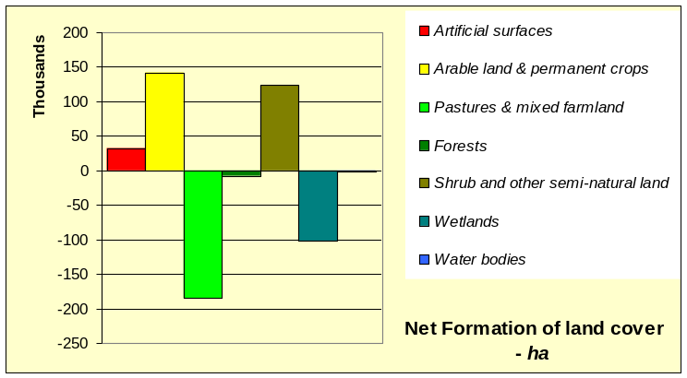
Old version of land accounts of Ireland, 1990-2000 (as presented in Dublin, 28-30 April 2004)
Source: Corine land cover (Provisional results as of 20 July 2004)

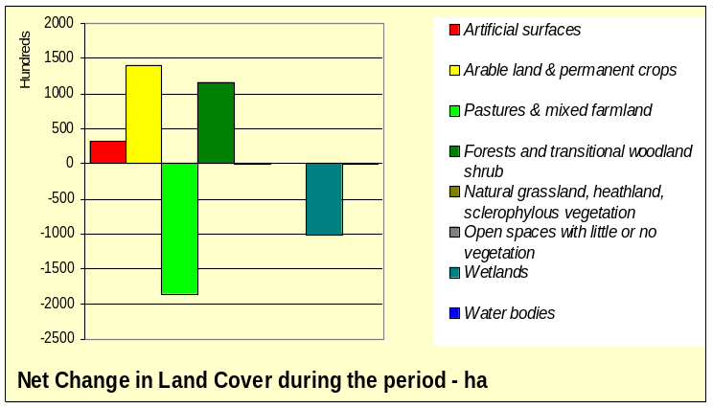
New version of land accounts of Ireland, 1990-2000 (as presented in Malahide, 25-27 May 2004), Source: Corine land cover
(Provisional results as of 20 July 2004)

- Forest and transitional woodland accounts from CLC

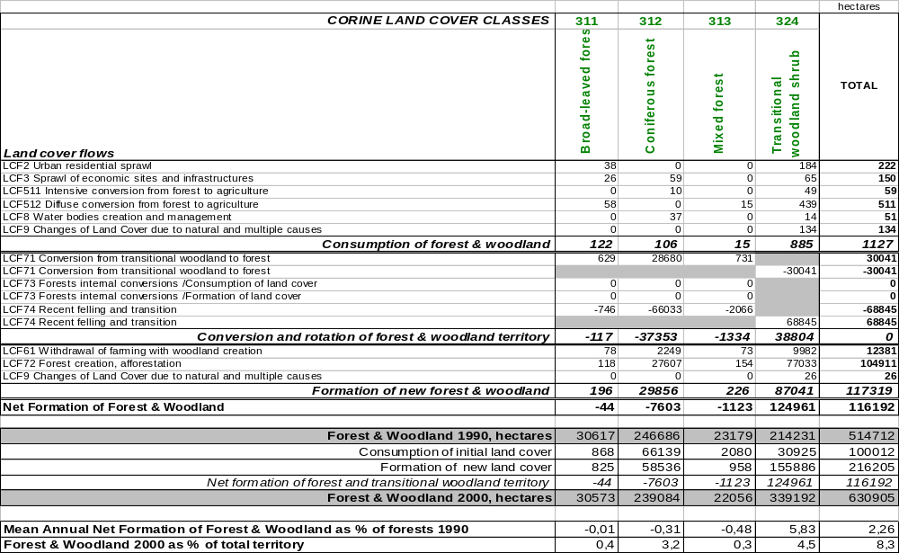 Ireland, 1990-2000, Source: Corine land cover (Provisional results as of 20 July 2004)

The following charts illustrate the main indicators.

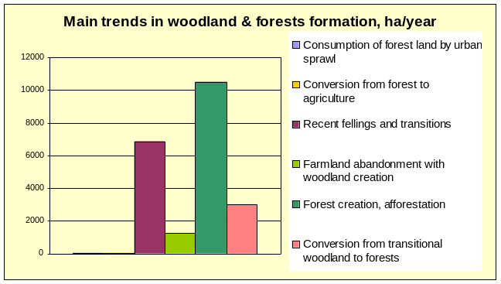
Ireland, 1990-2000, Source: Corine land cover (Provisional results as of 20 July 2004)

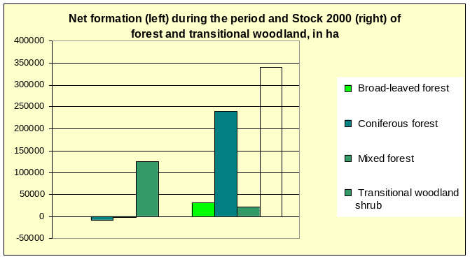
Ireland, 1990-2000, Source: Corine land cover (Provisional results as of 20 July 2004)

- Comparison between CLC and National inventory statistics

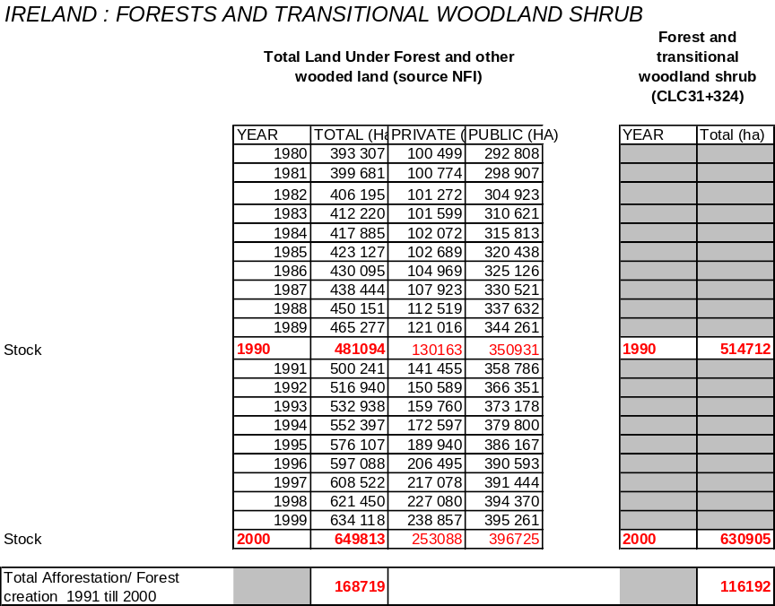

Regarding stocks, Corine numbers differ to some extent from NFI’s, by 7% (1990) and 3% (2000). Concerning the change between 1990 and 2000, this amounts to 35% on the basis of NFI’s figures (94% for private forests, 13% for public) and 23% on the basis of CLC.

A first reason for these remaining differences is that CLC maps land units that are not pure but can include patches smaller than 25 ha. This is part of the definition of the so-called mixed classes, in particular “Discontinuous urban fabric” and, even more importantly, “Agriculture land with significant areas of natural vegetation”, of which there are around 400000 ha where woods of less than 25 ha may be present. But some small (<25 ha) forest patches may exist as well in more homogenous land covers such as pasture or peatland.

Two other reasons for the differences are possible but need to be checked further:

- Variations in the exact dates on which the inventories were made

- Variations in the methodologies of the inventories themselves, e.g. the density of tree-crowns coverage

- Consequences for the assessment of forest creation and afforestation on peat bogs.

The change in definitions from conversion from peatbogs to coniferous forest (first version) to Forest creation, afforestation on peatbogs (new version) leads to a multiplication by 4 of the flow, namely from 24138 ha to 98519 ha. This is illustrated by the following maps:

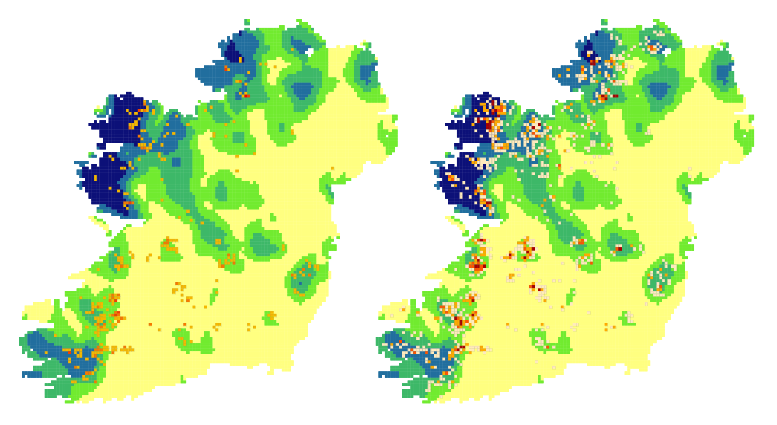
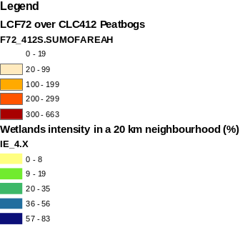

Ireland, 1990-2000:
Conversion of peatbogs to coniferous creation (left)
vs total Forest creation and afforestation on peat bogs (right)
Source: Corine land cover (Provisional results as of 20 July 2004)

Forest creation is presented by grid cells of 3x3 km (= 900 hectares). Only cells with changes higher than 20 ha are mapped in order to eliminate effects linked to geometry. Maximum values are of 392 ha (first map) and 663 ha (second map). Probably less precise than the National Forest Inventory, the land cover accounts give however an interesting picture of the distribution of afforestation and of the areas where it may impact.

